I233018
AbdulBasit
LAB5

Q1:

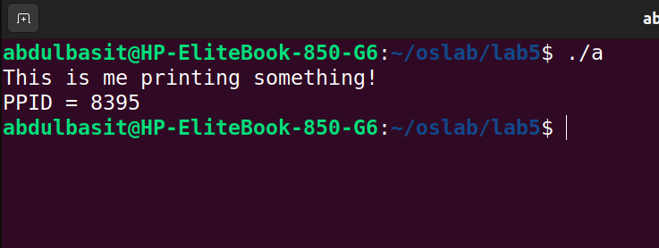
CODE:
#include <stdio.h>
#include <unistd.h>

int main()
{

printf("This is me printing something!\n");
printf("PPID = %i",getppid());
printf("\n");

return 0;
}

Q2:
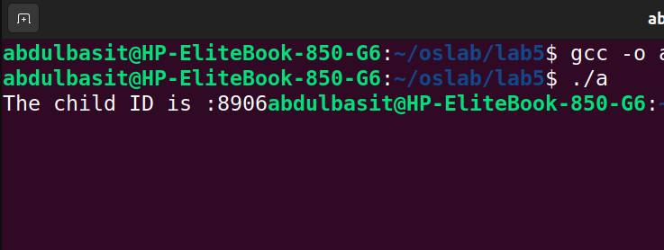
#include <stdio.h>
#include <unistd.h>

int main()
{
pid_t childID=fork();

if(childID>0)
printf("The child ID is :%d",childID);

return 0;
}

Q3:
CODE:
#include <stdio.h>
#include <unistd.h>

int main()
{
pid_t childID=fork();

if(childID==0)
{
sleep(0.2);
printf("The child process is TERMINATED");
}
else
printf("The parent process is TERMINATED\n");

return 0;
}
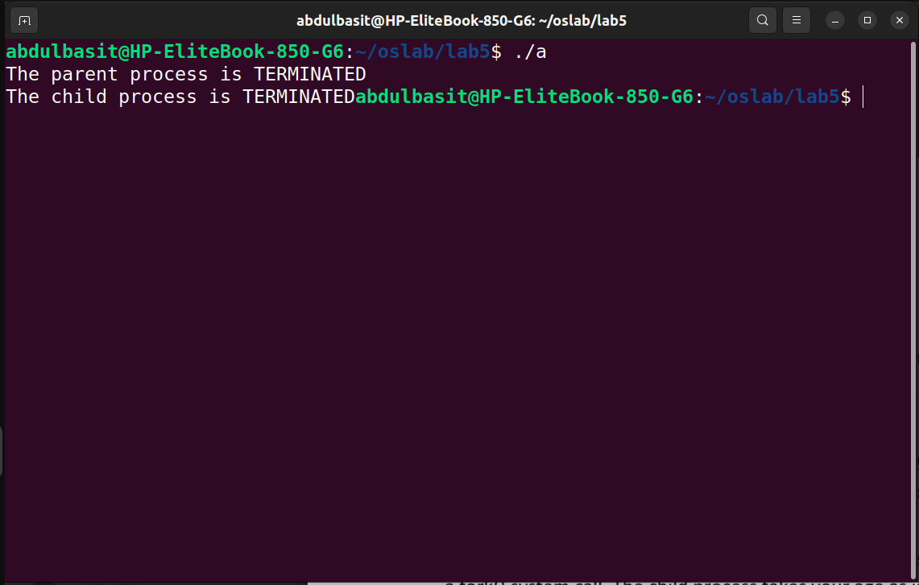
Q4:
CODE:
#include <stdio.h>
#include <unistd.h>
#include <stdlib.h>
#include <sys/wait.h>

int main()
{
pid_t childID=fork();

if(childID==0)
{
int x;
printf("Welcome to CHILD PROCESS!\nPlease Enter your Age: ");
scanf("%d",&x);
exit(x);
}
else
{
int age;
wait(&age);
int childAge=WEXITSTATUS(age);
printf("\nWelcome to the PARENT PROCESS\n Your Age is %d\n",childAge);
}

return 0;
}
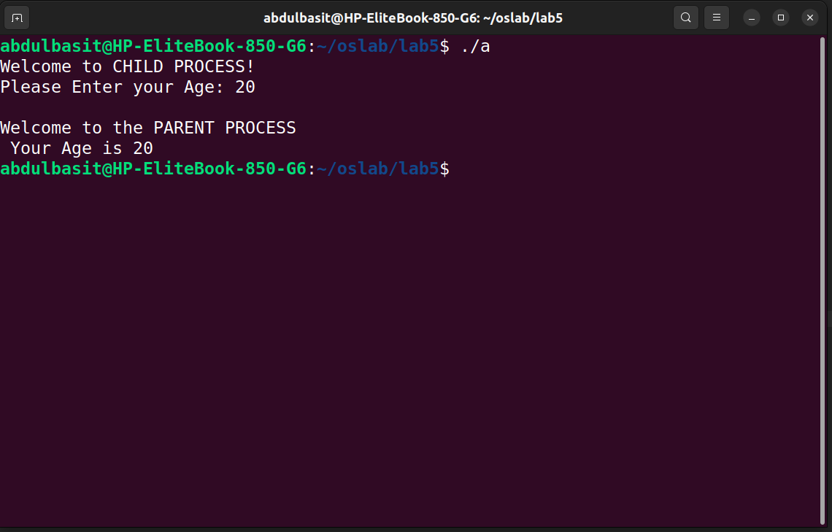
Q5:
CODE:
#include <stdio.h>
#include <unistd.h>
#include <stdlib.h>
#include <sys/wait.h>
#include <time.h>
#include <stdbool.h>

bool isPrime(int n)
{
if (n <= 1)
{
return false;
}
for (int i = 2; i * i <= n; i++)
{

if (n % i == 0)
{
return false;
}
}
return true;
}

int main()
{
srand(time(NULL));
int array [1000];

for(int i=0;i<1000;i++)
array[i]= (rand() %100)+1;

pid_t child=fork();

if(child==0)
{
printf("CHILD 1\n");
int totalPrimes=0;
for(int i=0;i<500;i++)
{
if(isPrime(array[i]))
totalPrimes++;
}
printf("Total Primes till 1-500 are %d\n",totalPrimes);
}
else
{
//parent
wait(NULL);
pid_t child2 = fork();
if(child2==0)
{
printf("CHILD 2\n");
int totalPrimes=0;
for(int i=500;i<1000;i++)
{
if(isPrime(array[i]))
totalPrimes++;
}
printf("Total Primes till 500-1000 are %d\n",totalPrimes);
}
else
{
wait(NULL);
}
}

}
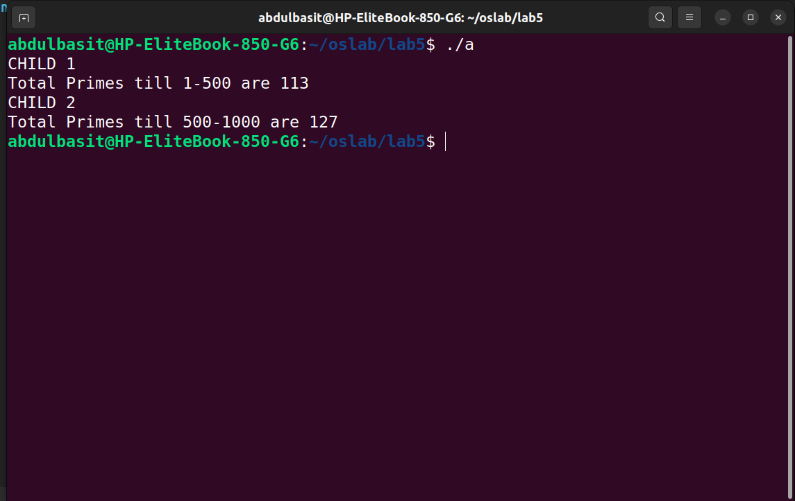
Q6:
CODE:
#include <stdio.h>
#include <unistd.h>
#include <stdlib.h>
#include <sys/wait.h>
#include <time.h>
#include <stdbool.h>

int main()
{

char * newVars[]={"MY_VAR=HELLO WORLD",NULL};

execle("/usr/bin/env","env",NULL,newVars);

}
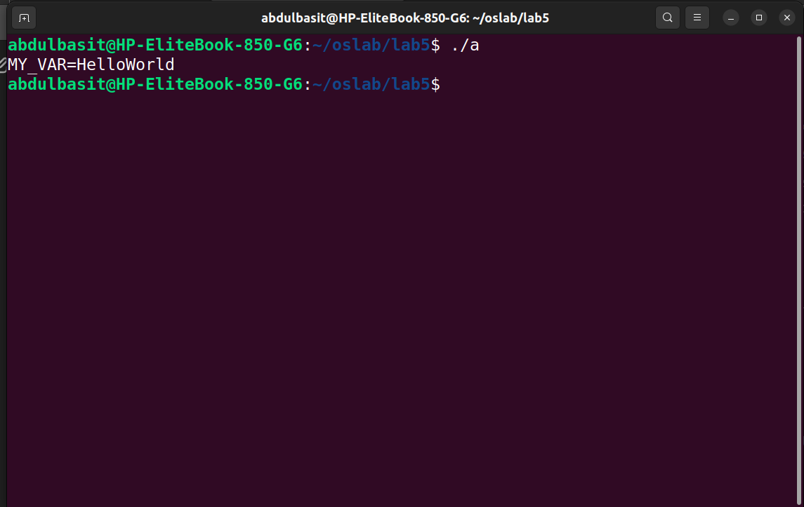
Q7:
CODE
#include <stdio.h>
#include <unistd.h>
#include <stdlib.h>
#include <sys/wait.h>
#include <time.h>
#include <stdbool.h>

int main()
{
char inputCommand[20];
printf("Enter the command : ");
scanf("%20s",inputCommand);

char * args[]={inputCommand,NULL};

execvp(inputCommand,args);

}
